AWS Data Analytic Platform for The City of Vancouver

“Phase 1”

Group #2

Luis Esteban Juarez Marquez (2311664)

Daniel Alexander Frederic Curling (2235630)

Tej Pratap Singh (2207494)

University Canada West

BUSI 653: Cloud Computing Technologies (FALL24-09)

Prof. Mahmood Mortazavi Dehkordi

November 26, 2024

Table of Contents

Introduction (Teamwork) 4

DAP Design and Implementation (Individual work – Esteban Juarez 2311664 #1) 5

Descriptive Analysis 5

**Step 1: Data Ingestion** 6

Step 2: Data Profiling 7

Step 3: Data Cleaning 9

Step 4: Data Pipeline Design 10

Exploratory Analysis 12

Step 1: Data Ingestion 12

Step 2: Data Profiling 13

Step 3: Data Cleaning 13

Step 4: Data Pipeline Design 14

DAP Design and Implementation (Individual work – Daniel Curling) 17

Descriptive Analysis 17

Step 1: Data Ingestion 18

Step 2: Data Profiling 20

Step 3: Data Cleaning 22

Step 4: Data Pipeline Design 23

Exploratory Analysis 25

Step 1: Data Ingestion 25

Step 2: Data Profiling 25

Step 3: Data Cleaning 25

Step 4: Data Pipeline Design 26

DAP Design and Implementation (Individual work – Tej Pratap Singh) 28

Descriptive Analysis 28

Step 1: Data Ingestion 29

Step 2: Data Profiling 30

Step 3: Data Cleaning 32

Step 4: Data Pipeline Design 33

Exploratory Analysis 35

Step 1: Data Ingestion 36

Step 2: Data Profiling 36

Step 3: Data Cleaning 37

Step 4: Data Pipeline Design 38

DAP Estimated Cost (Teamwork) 40

References 41

# Introduction (Teamwork)

Efficient data management and clear analysis are essential steps to be taken in urban planning and city governance, all these being greatly necessary in a big multicultural city such as Vancouver. The development of a data analytics platform is a handy tool for the government of Vancouver to efficiently analyze, manage and create actionable insights that are derived from datasets. A data analytic platform would enable accurate decision-making with up-to-date data ensuring accountability and transparency that benefit citizens and governments. Based on the previously mentioned points, this assignment will leverage a data analytic platform based on AWS services to design and implement this DAP that supports descriptive and exploratory analysis in different areas.

The main objective of the project is to address key questions that will be answered through the data analytic platform and the output. Questions such as monthly distribution of building permits in Downtown Vancouver 2024, participation in council elections for specific dates and lost rates in participation are among the questions to be answered. Our data analytic platform follows all the steps, first obtaining the data from the official website of “The city of Vancouver” and then beginning the data ingestion into S3, cleaning and profiling is done through AWS Glue Data Brew for all our datasets and finally transformed and analyzed via AWS Glue, with the final output stored back into S3 buckets.

The Importance of having this Data Analytic Platform relies in its ability to streamline workflows, improving the accuracy of the data while maintaining data cleanness, and obtaining actionable insights for outcome from processing the raw datasets. Further in the body of this assignment the sections will detail the parts of the data analytic platform, different methods to create data pipelines and provide comparisons of how the DAP successfully processed data.

# DAP Design and Implementation (Individual work – Esteban Juarez 2311664 #1)

## Descriptive Analysis

**Question: How many building permits are issued per month in Downtown Vancouver in 2024?**

Figure 1 Draw.io diagram for Descriptive Analysis. (Source Author)

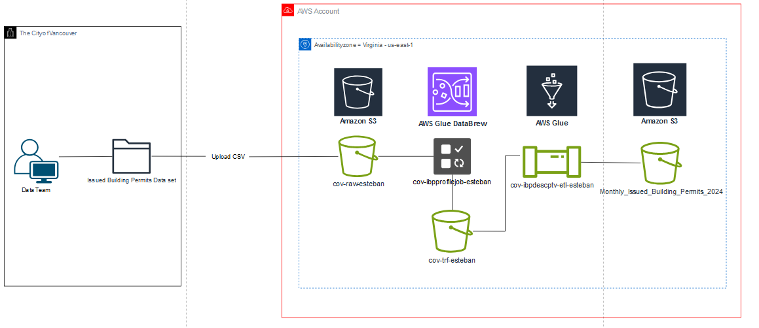

## **Step 1: Data Ingestion**

Figure 2 Filtered Dataset of Issued Building permits in City of Vancouver website. (Source Author)

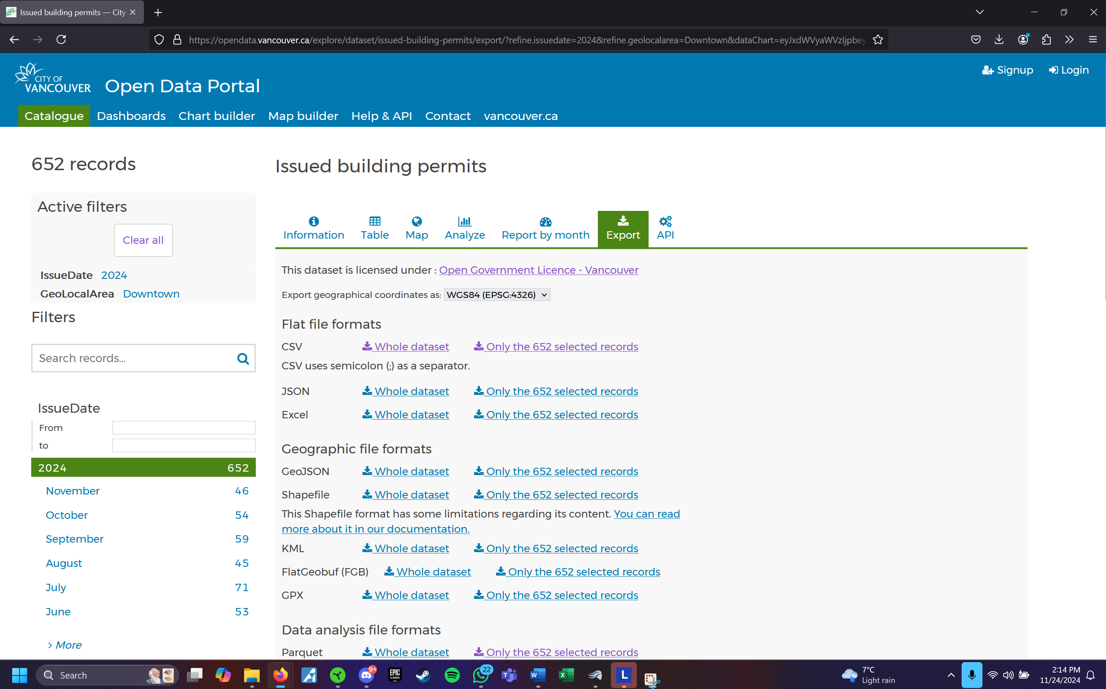

For Data ingestion, first I picked the dataset “Issued Building Permits” and filtered for the year 2024 and to only the GeoLocalArea of Downtown Vancouver, which comes down to only 648 records as per the date of 11/23/24. After downloading the CSV fille, I proceeded to my AWS account to create the buckets in S3.

Figure 3 S3 Buckets created for the Data Analytic Platform (Source: Author)

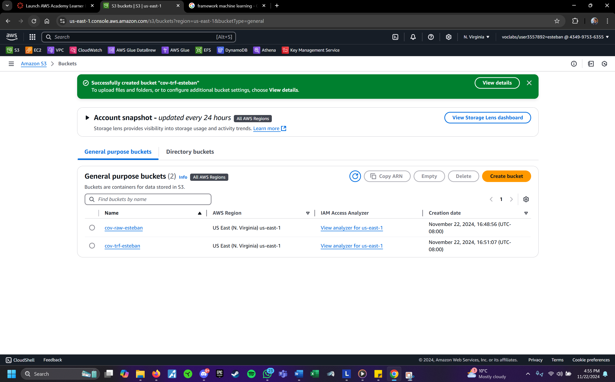

First I created a “raw” bucket for uncleaned and unprocessed data, in this case the CSV data set I filtered and downloaded from the City of Vancouver website, and a “trf” folder, which contains folders for data that has been cleaned through AWS Glue databrew as well as the “system” and “user” folders for the AWS glue output.

## Step 2: Data Profiling

Figure 4 Folders within the transform bucket for data cleaning and profiling (Source: Author)

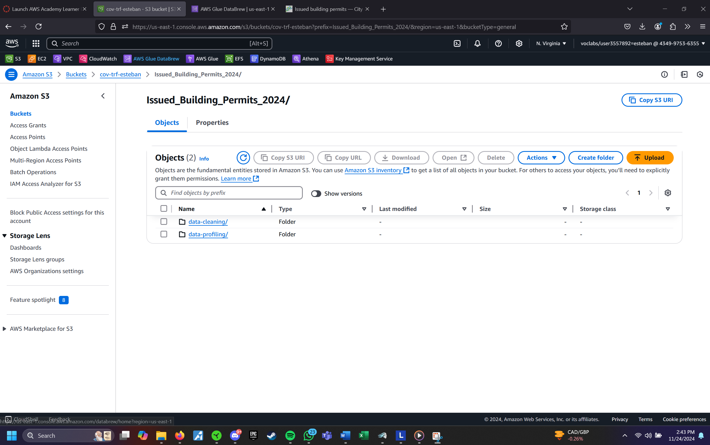

As mentioned above, the “trf” folder contains the folders for “data-cleaning” and “data-profiling”.

Figure 5 Initial state of the data before profiling, needs some missing values to be dealt with. ( Source: Author)

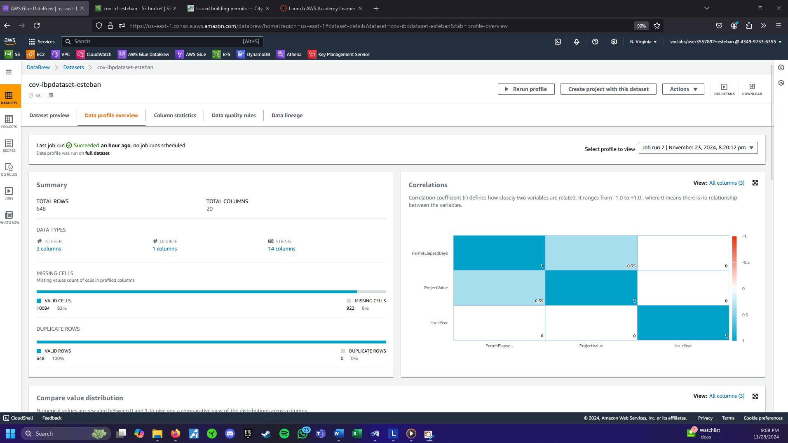

After creating the dataset in AWS Databrew, we have some missing values as well as some date formats to change so I could achieve a usable dataset.

Figure 6 Dataset after profiling and cleaning, all of the columns are now quality data (Source: Author)

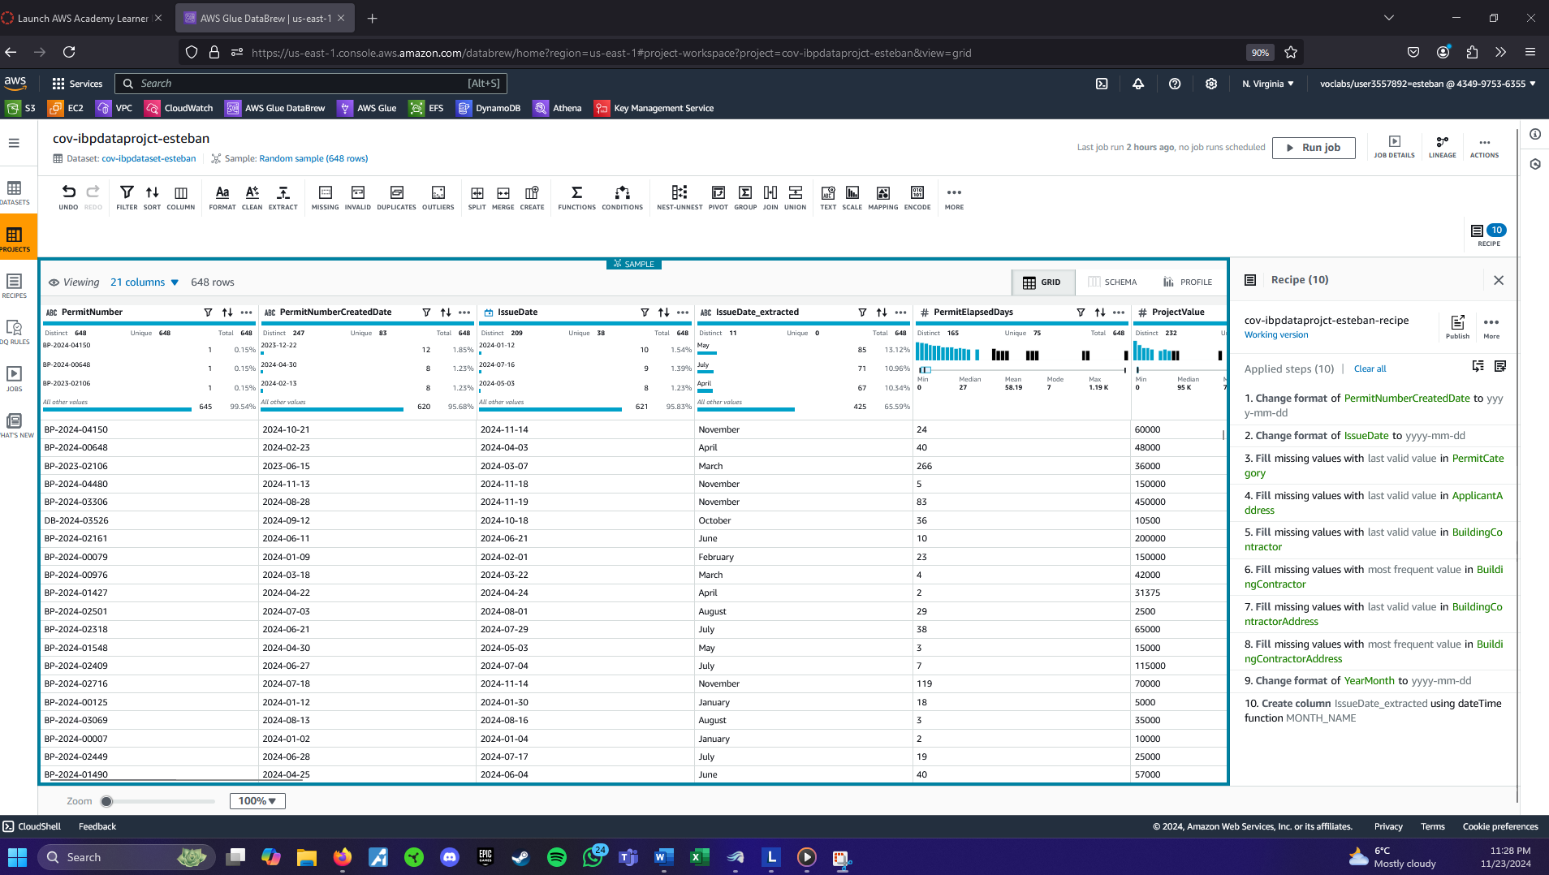

## Step 3: Data Cleaning

Figure 7 Recipe and steps followed for data profiling and cleaning for dataset. (Source: Author)

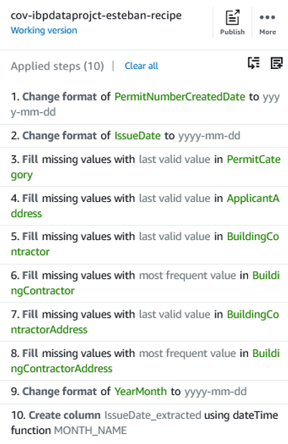

For data cleaning, nulls where dealt by using the last valid value, the reason this was done is because the result of going for this method provided the most accurate result and the answers within the data base weren’t as clear for the purpose of building, however after the final result, the percentage matched the data base of the city of Vancouver. Date format was standardized across creation and issue date of issuance, additionally the month in which the permit was issued was extracted and converted to month for the analysis.

## Step 4: Data Pipeline Design

Figure 8 Pipeline for descriptive analysis question resolution and data processing. (Source: Author)

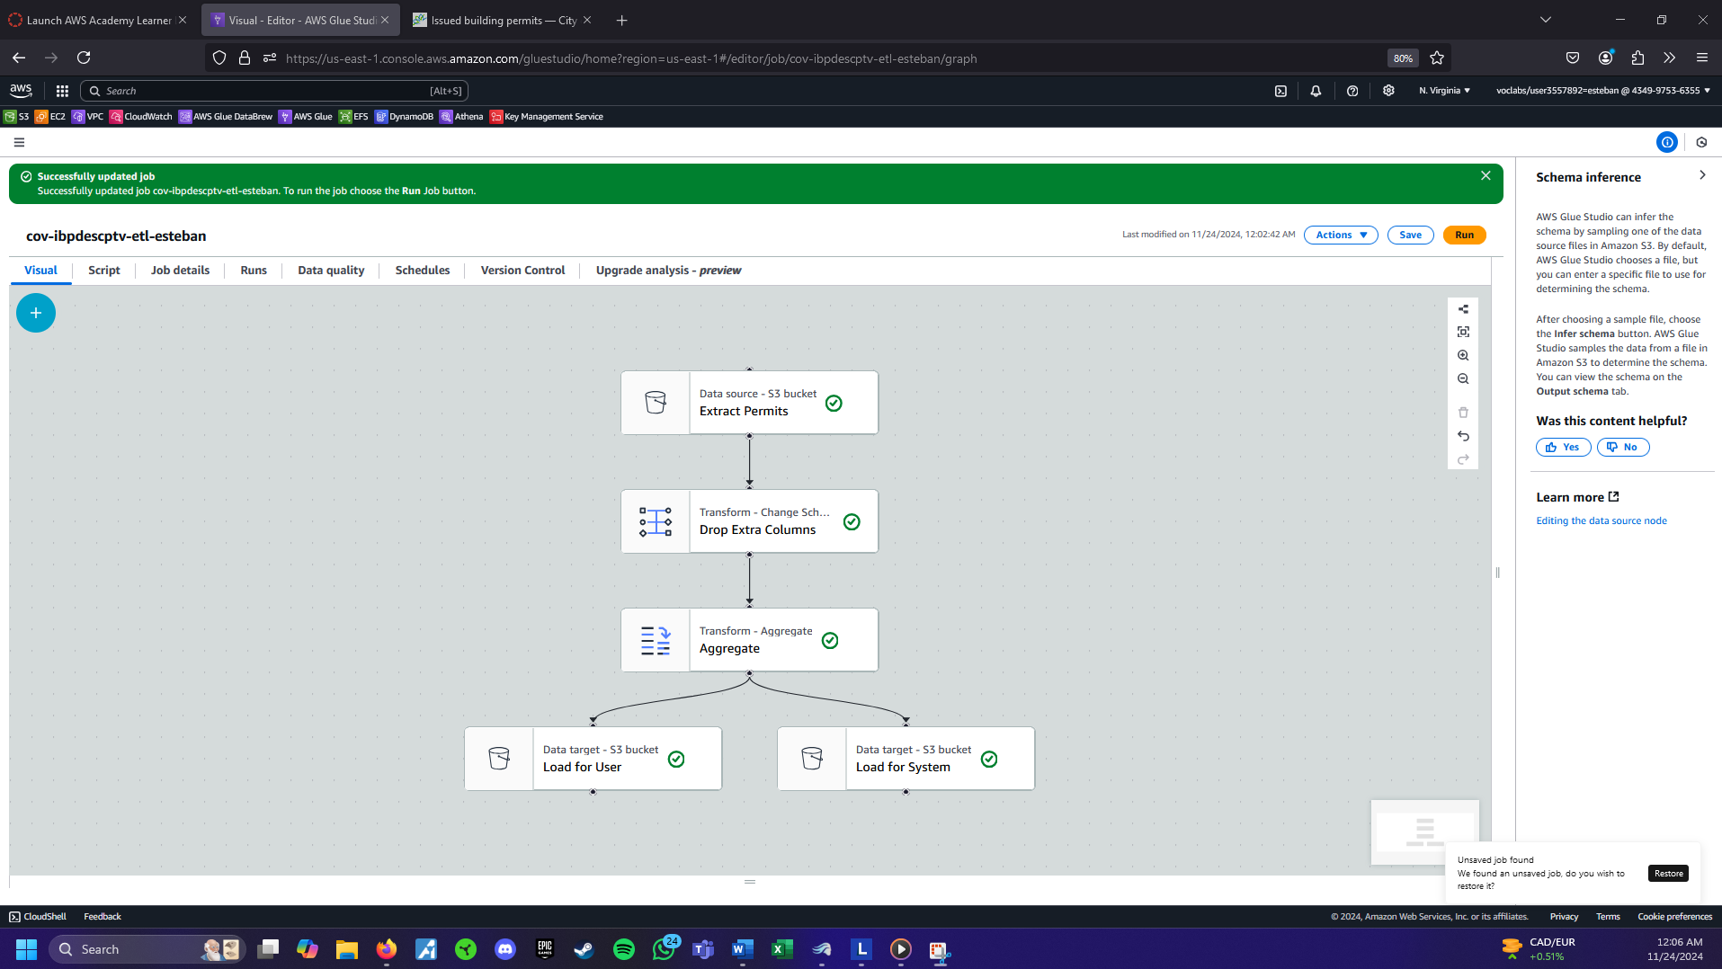

The flow to answer the question was actually a bit simpler, first, we bring the dataset with an S3 Bucket, then the transform is used to drop all extra columns such as geographical coordinates, constructor company names, among other columns. Then an aggregate is used to finally answer the question, “How many permits are issued per month in Vancouver at 2024?”.

Figure 9 Outcome of the pipeline for permits issued per month in downtown Vancouver (Source: Author)

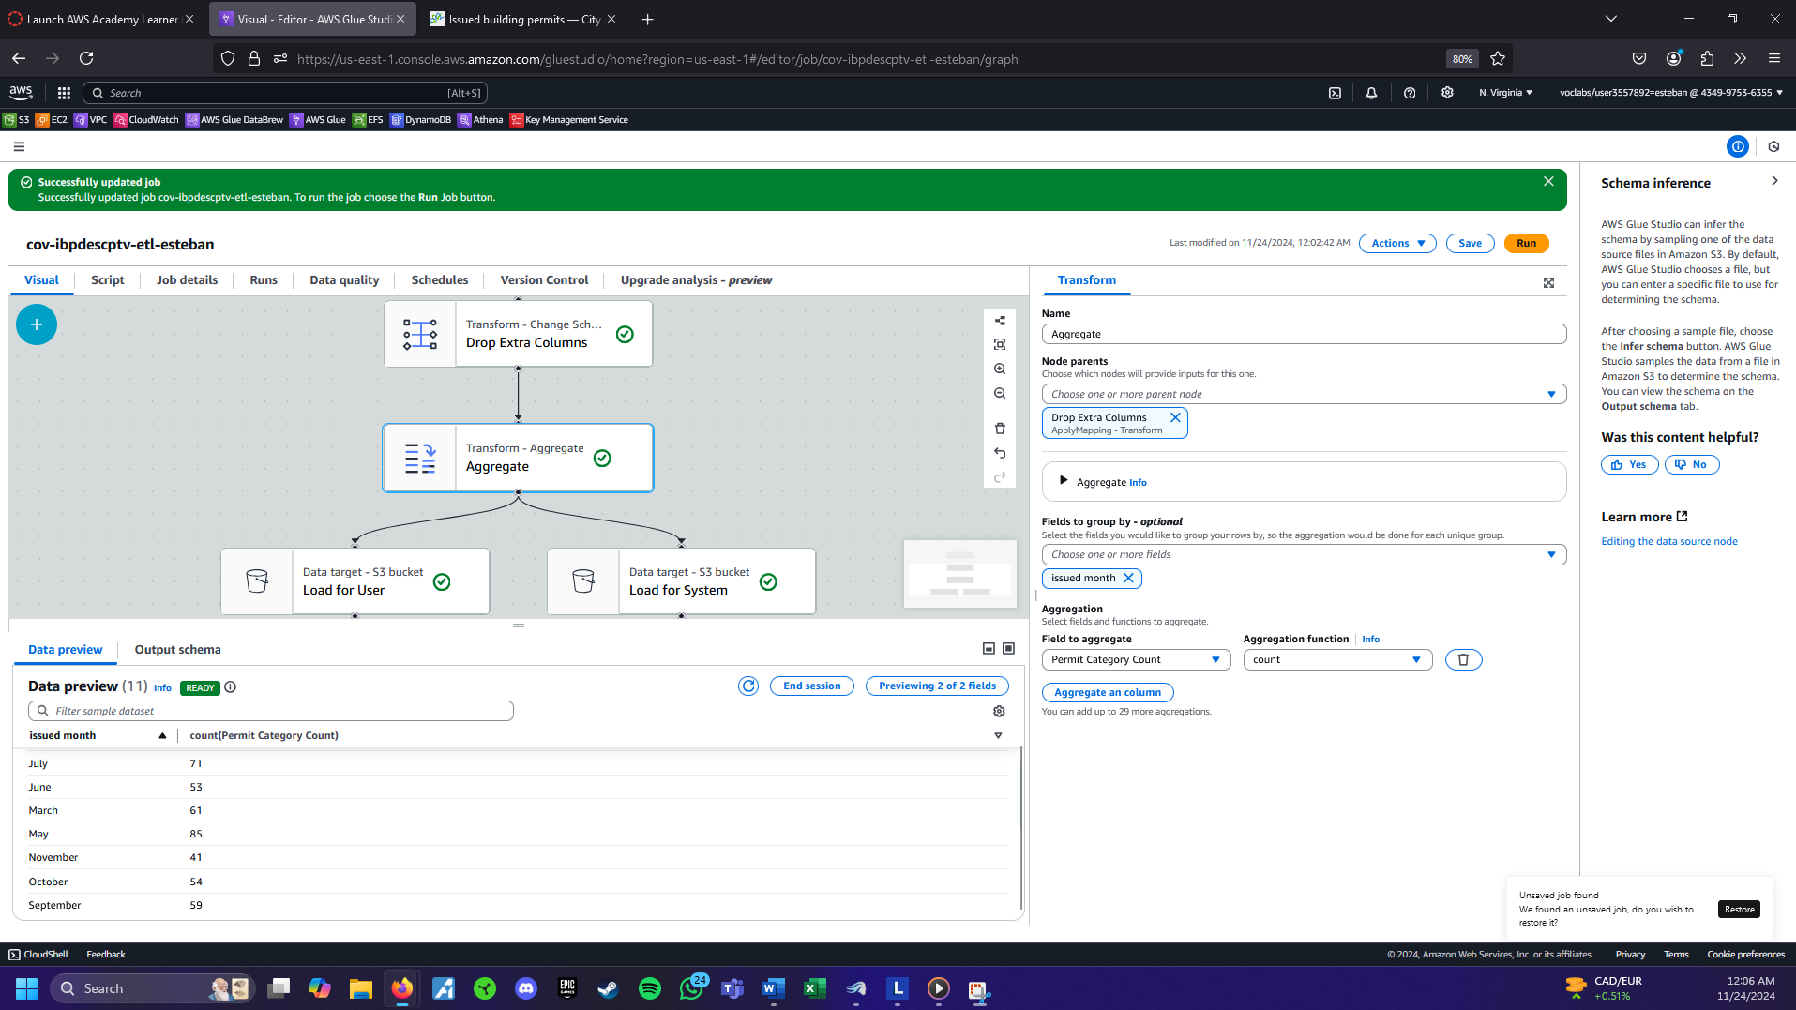

Figure 10 Screenshot of the data to verify that the pipeline achieved the same results. (Source : opendata.vancouver.ca)

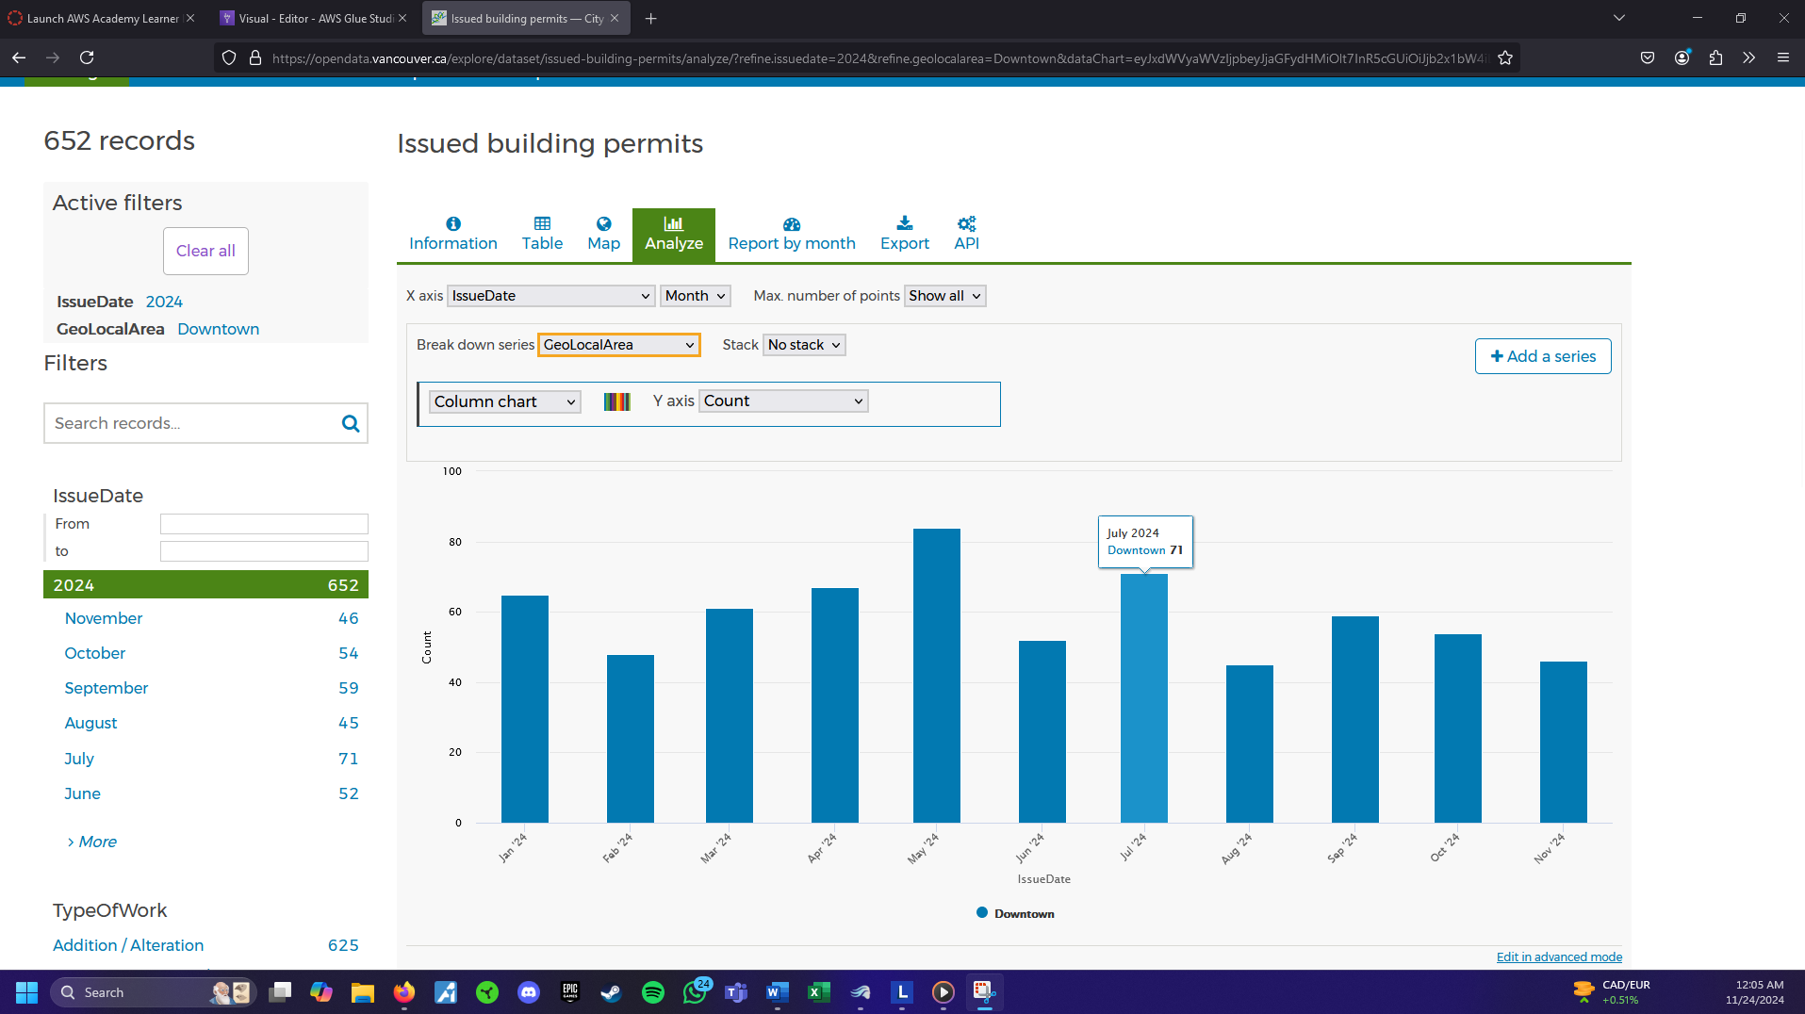

When Comparing the results of the AWS Glue and the City of Vancouver dataset, I can safely say that the transfer to AWS platform was successful in a streamlined and lean pipeline. As the screenshots show, July has a 71 count of permits in both the AWS Glue and original dataset chart.

## Exploratory Analysis

**Question: What is the rate of Residential building permits in Downtown Vancouver in 2024?**

Figure 11 Draw.io Diagram for Exploratory analysis data analytic platform (Source: Author)

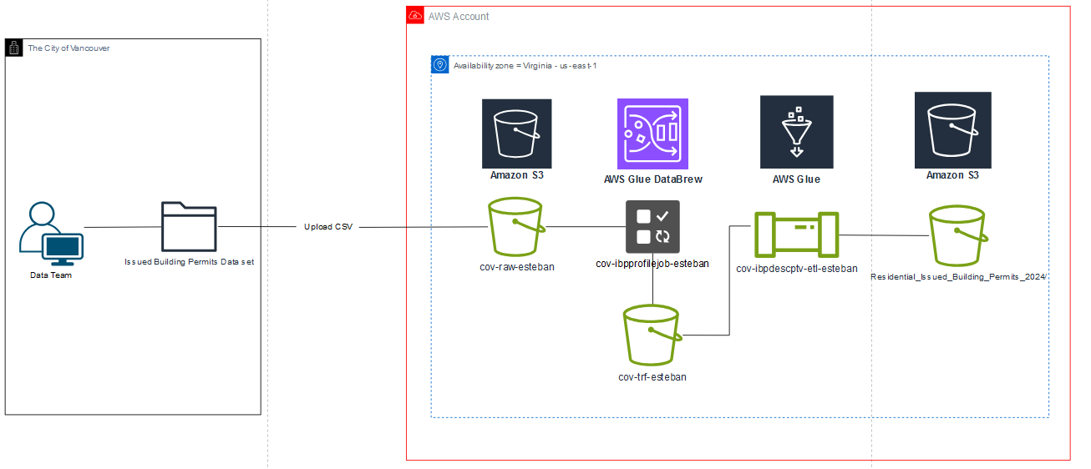

## Step 1: Data Ingestion

Figure 12 Data ingestion was the same process since the same dataset is used for exploratory analysis. (Source: Author)

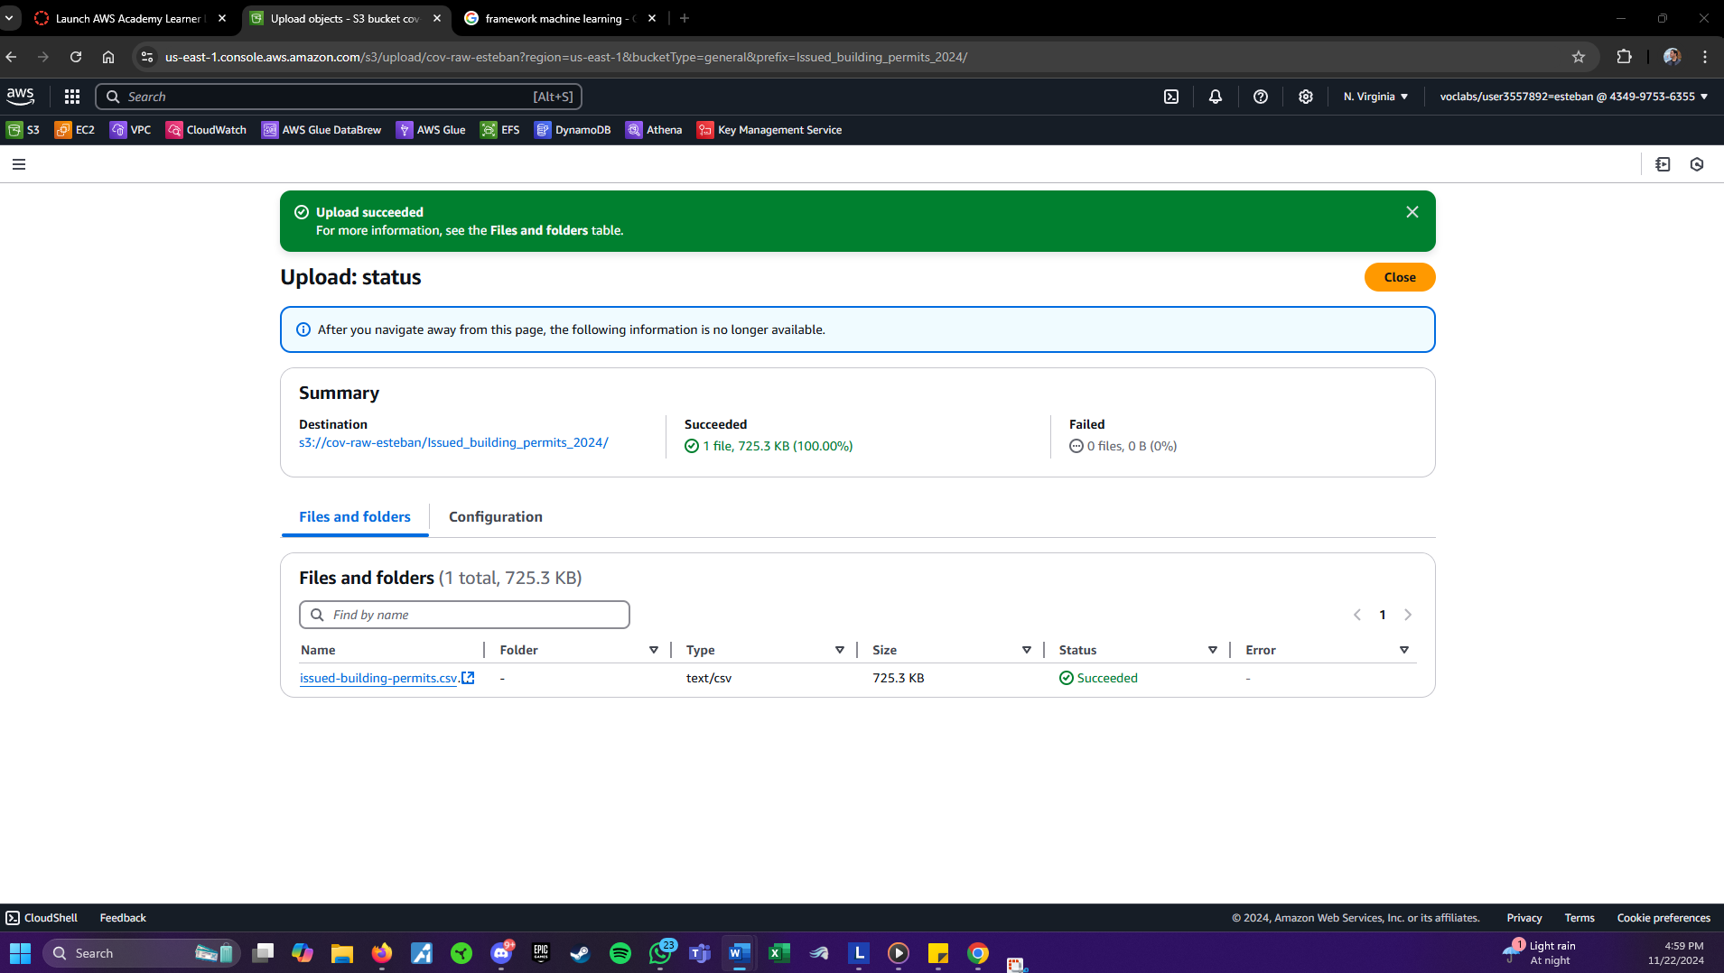

For data ingestion the process was the same as for the descriptive analysis, since the same data set is going to be used to answer the question for the exploratory analysis.

## Step 2: Data Profiling

Figure 13 Data profiling output locations for both, System and User. ( Source: Author)

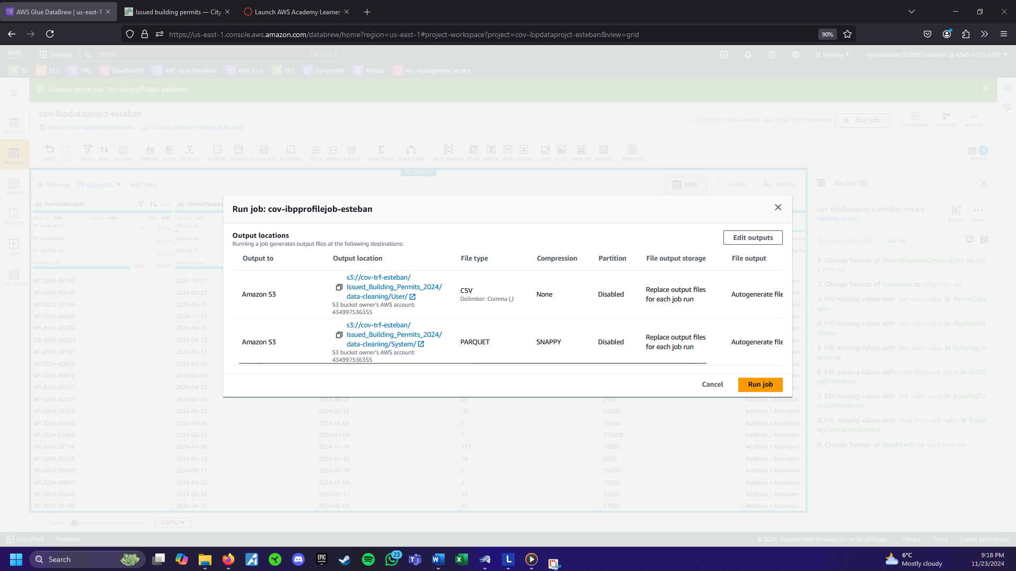

Data profiling was the same, with the addition of putting an eye on the types of permits issued. Since this is the key column to answer the question.

## Step 3: Data Cleaning

Data cleaning is the same for this point, please refer to figure 6 for reference.

## Step 4: Data Pipeline Design

Figure 14 Pipeline design for exploratory analysis, all of the nodes reviewed in class were used. (Source: Author)

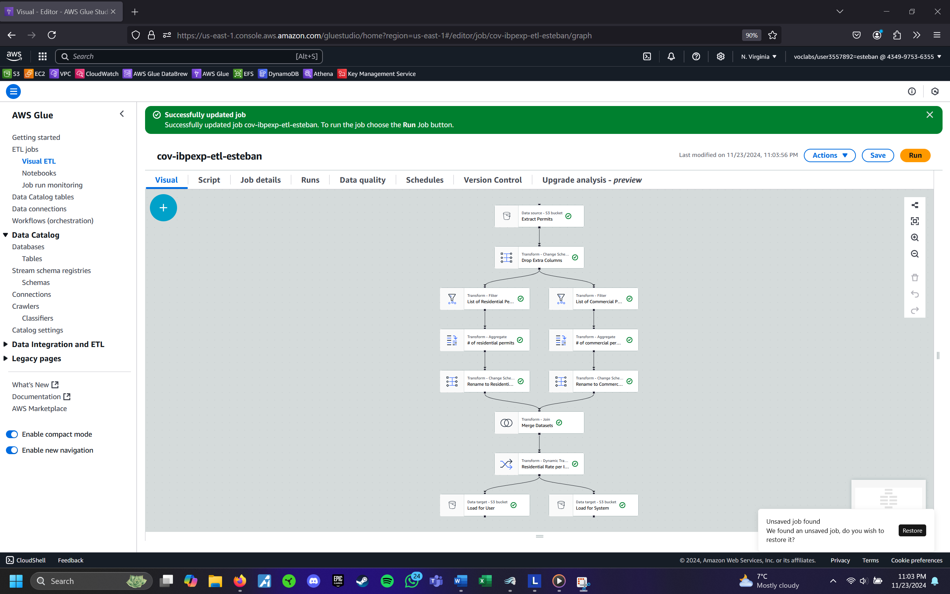

The data pipeline for the exploratory analysis is a bit more complicated, first we bring the S3 dataset, after that I dropped the extra columns, then it is split into 2 different streams, it is necessary to filter the data set in only residential permits and only commercial permits. After the data is filtered, both sides are aggregated into a count and the change schema is added to change the name of the columns. After that, both datasets are joined to have both counts to get the rate of commercial permits in 2024.

Figure 15 Data preview showcases the rate of residential permits issued as of 2024 (Source: Author)

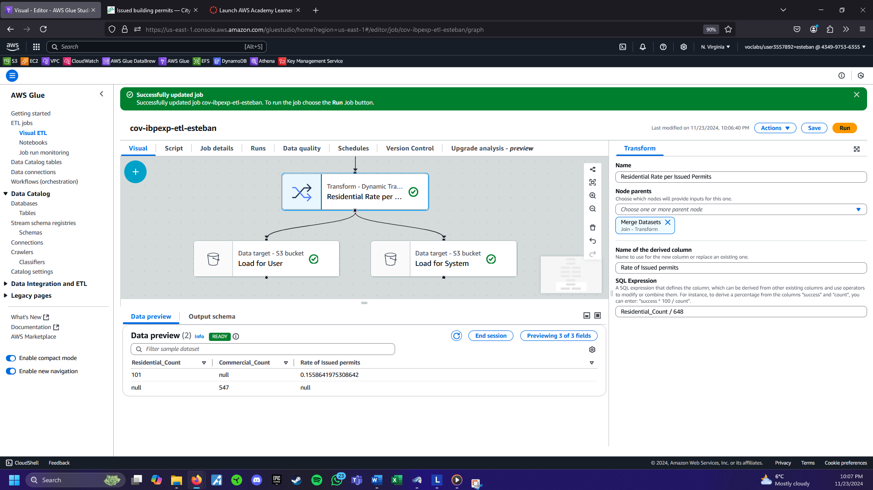

Figure 16 Screenshot from The City of Vancouver database that shows percentage to verify. (Source Author)

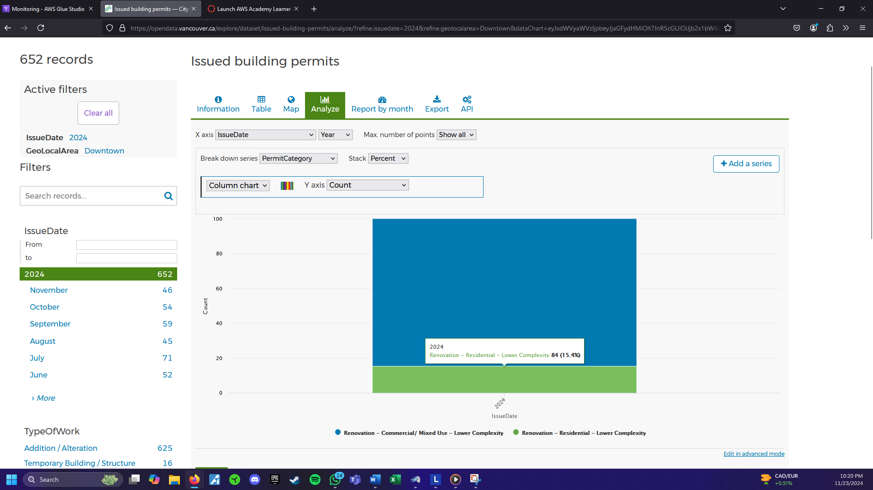

Note: (Slight difference in percentiles are due to dataset having more permits on Nov.23)

The derived node shows the rate of commercial permits is 15.58% of the number of permits issued by Vancouver city. This can be confirmed by the data set shown in the chart above extracted from The City of Vancouver website which shows 15.4% from the AWS glue. There is a small difference in the percentage, but this comes from the difference in the date the website was accessed, since the date the data was downloaded from the website there only was 648 permits.

# DAP Design and Implementation (Individual work – Daniel Curling)

## Descriptive Analysis

Question : How many males are employed in the workforce?

Figure 17 Draw.io diagram for Descriptive Analysis. (Source Author)

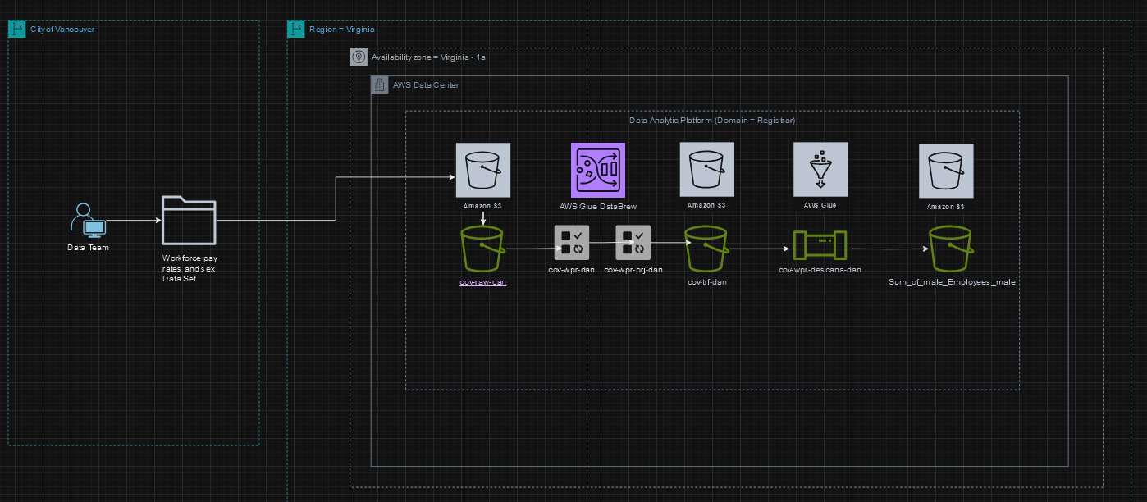

## Step 1: Data Ingestion

Figure 18 Website where dataset is captured from (Source opendata.vancouver.ca)

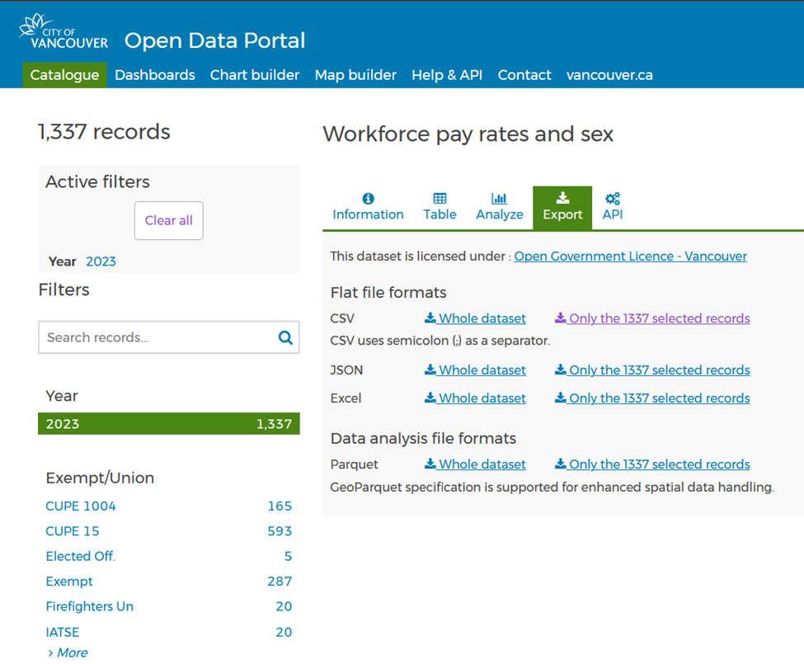

The dataset chose was “Workforce pay rates and sex”, filtered for the year 2023, no other filtering was done on the website as there were datapoints suppressed that would later be removed during cleaning. The initial number of records was 1337, file was downloaded on 11/24/24 and then uploaded to AWS bucket “cov-raw-dan” for further analytics explained below.

Figure 19 S3 Buckets for raw and transformed data (Source : Author)

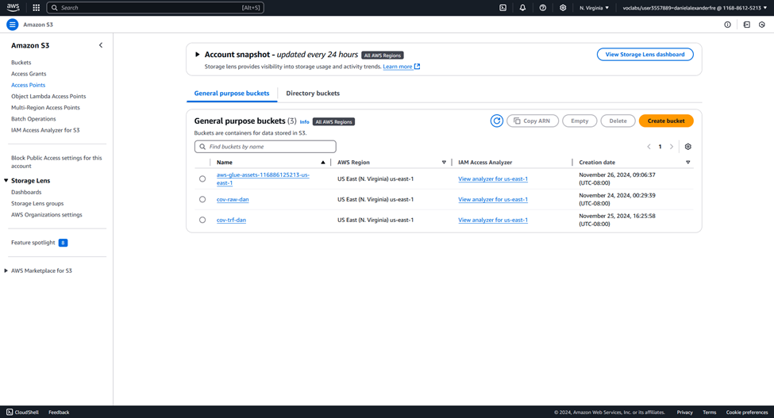

Figure 19 shows buckets created for raw data and transformed data as well as the file created by AWS after data profiling was completed on the dataset.

Figure 20 structure of raw folder (Source: Author)

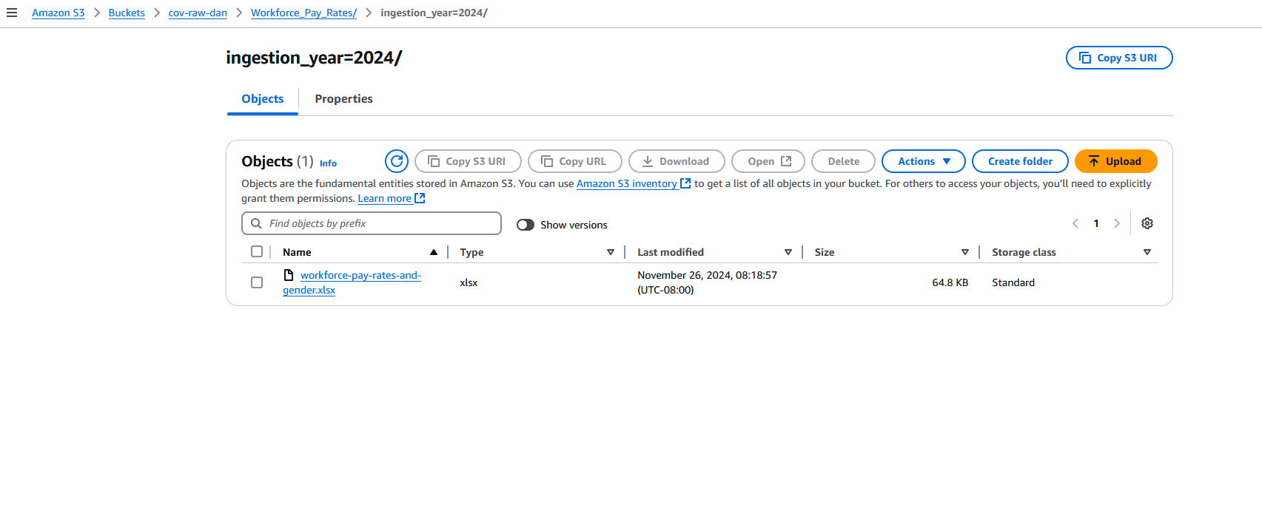

The above figure 20 shows the structure of the raw folder as well as the location the csv file was initially uploaded to.

## Step 2: Data Profiling

Figure 21 Structure of trf folder (Source: Author)

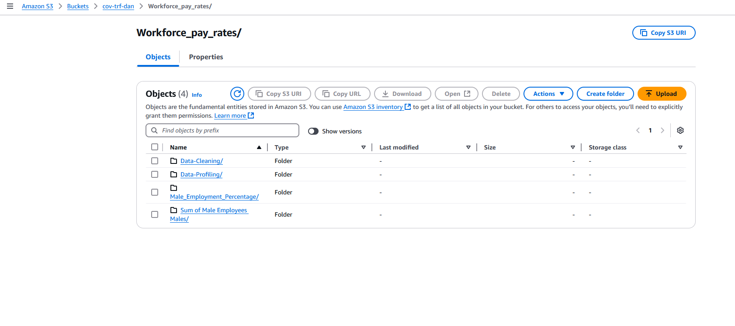

For data profiling, data is stored in the “trf” folder, where there is one folder for users and one for data that we will use within AWS named system.

Figure 22 Results of data profile overview (Source: Author)

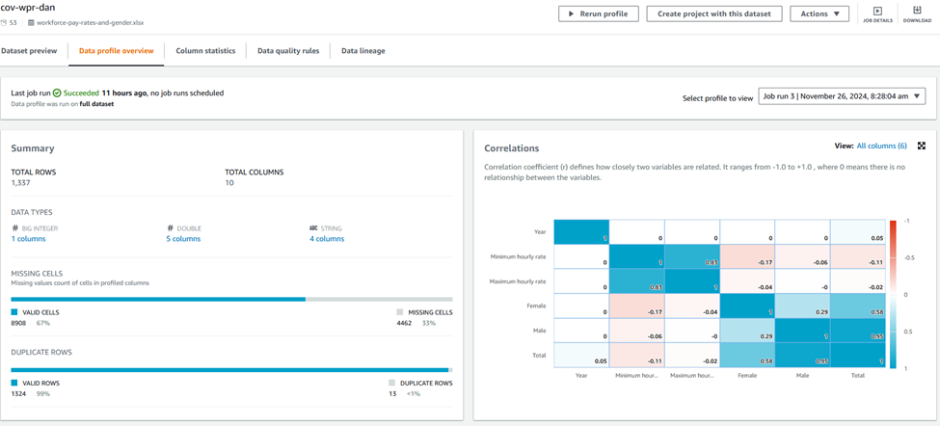

Figure 23 data profile overview (Source: Author)

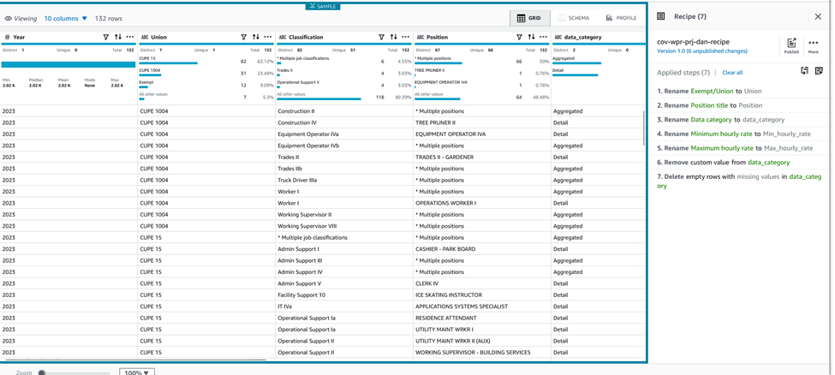

The above shows where data profiling was run on the dataset to provide us with an overview of the dataset so we can better understand it. The overview shows that we have 33% missing fields. This will be handled during the data cleaning process.

## Step 3: Data Cleaning

For the data cleaning process, we want to achieve a usable dataset. All the columns were renamed to suitable names for processing. After further review of the data, it was found that all data categorized as suppressed was missing from the dataset, as such this category was removed. No other cleaning was necessary.

Figure 24 recipe used for data cleaning (Source: Author)

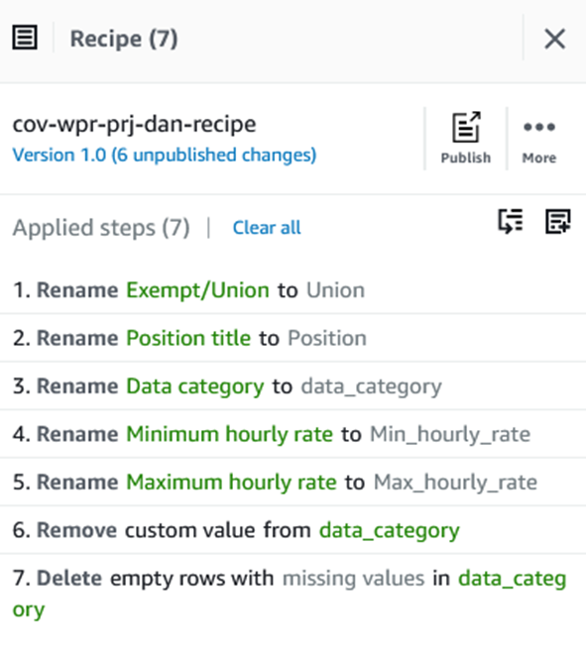

Above the recipe used for cleaning is shown.

## Step 4: Data Pipeline Design

Figure 25 Overview of data pipeline (Source: Author)

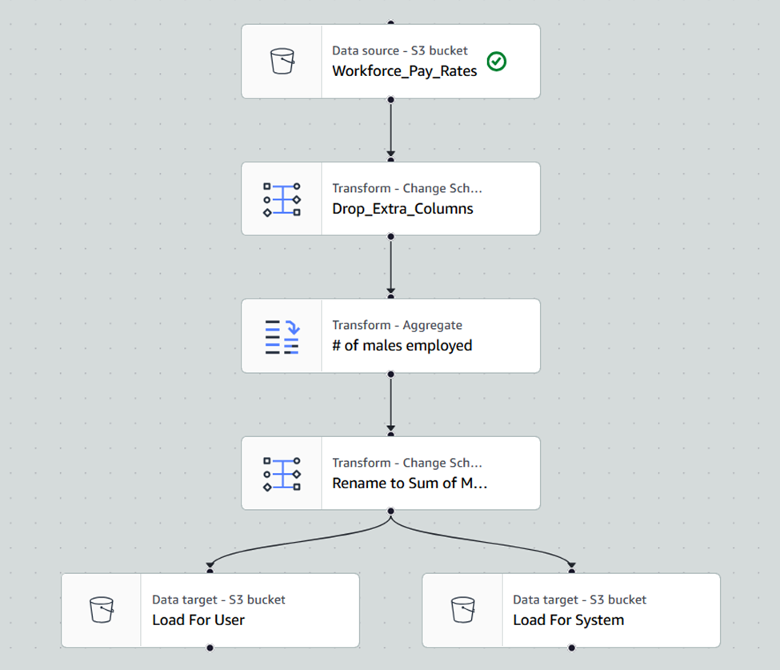

Figure 26 Data pipeline with results (Source: Author)

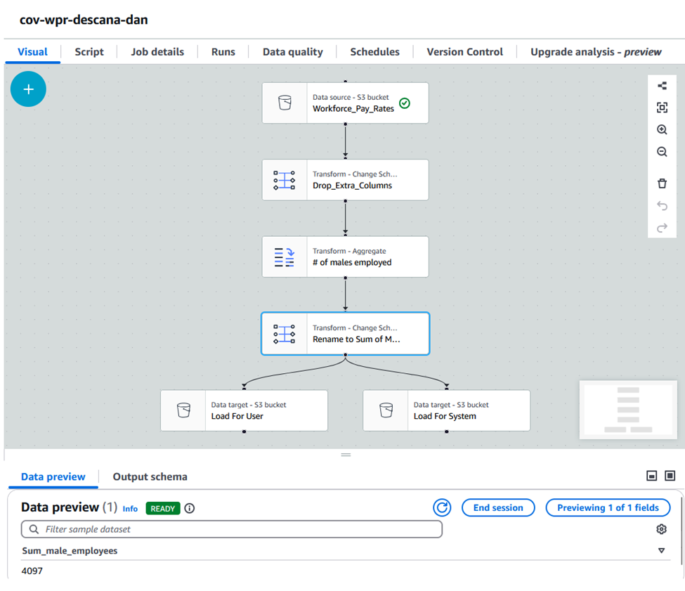

The data pipeline created to answer our question, “How many males are employed in the workforce”. To arrive at the answer I first dropped all unnecessary columns, then for the aggregate, retrieved the sum of the males in the “male” column, this data was then stored in two locations in S3, one for users as csv that can be read and understood by anyone wanting to view this data and one for the system stored as parquet that we can use for further analysis within AWS if needed. The number of males employed was 4097.

## Exploratory Analysis

Question: For each job position what is the percentage of male employees?

Figure 27 DrawIO diagram showing process for Exploratory Analysis (Source Author)

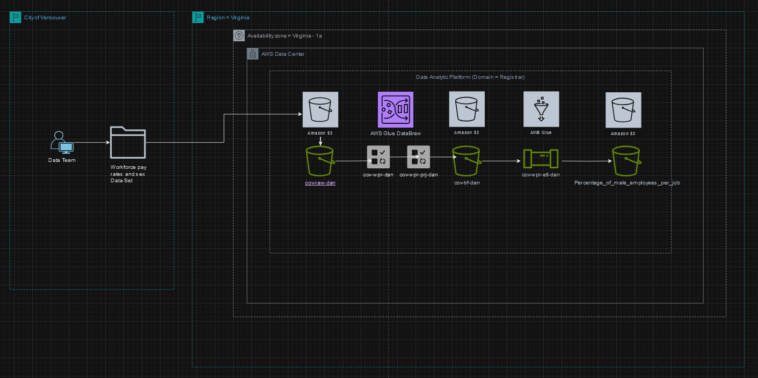

## Step 1: Data Ingestion

For exploratory analysis I used the same dataset as the one used for descriptive analysis, so Ingestion was the same.

## Step 2: Data Profiling

Data profiling was also the same as in the descriptive analysis phase.

## Step 3: Data Cleaning

Data cleaning was also the same as in the descriptive analysis phase.

## Step 4: Data Pipeline Design

Figure 28 Data Pipeline Overview (Source: Author)

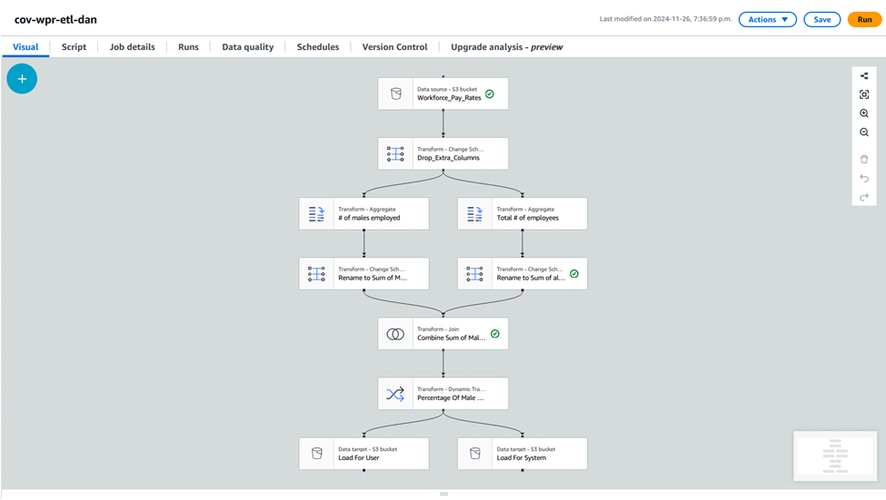

Figure 29 Data Pipeline showing sample results (Source: Author)

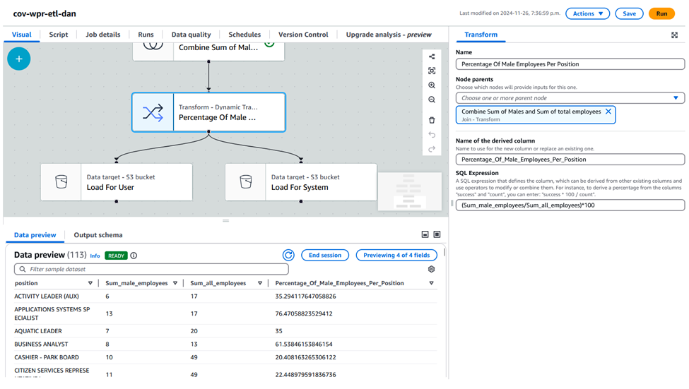

The data pipeline used to answer the exploratory analysis question started with importing the dataset and removing columns that were not needed. The data was then split into two streams, one to find the number of males employed for each job, and one to find the total number of employees (male and female) for each job. After these aggregations were done, the data was then joined so that calculations could be done on the information gathered. To find the percentage of males in each job role the formula “(Sum_male_employees/Sum_all_employees)*100”, this resulted in displaying the percentage of males in each job role as can be seen in figure X??.

# DAP Design and Implementation (Individual work – Tej Pratap Singh)

## Descriptive Analysis

Question: - How many Candidates have taken part in Council elections in the month of October?

Figure 30 Draw.io diagram for Descriptive Analysis. (Source Author)

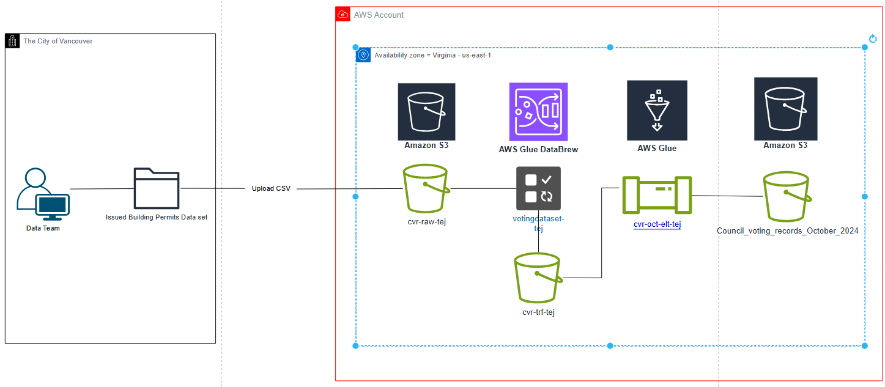

## Step 1: Data Ingestion

Figure 31 Filtered Dataset of Council Voting Record in City of Vancouver website. (Source Author)

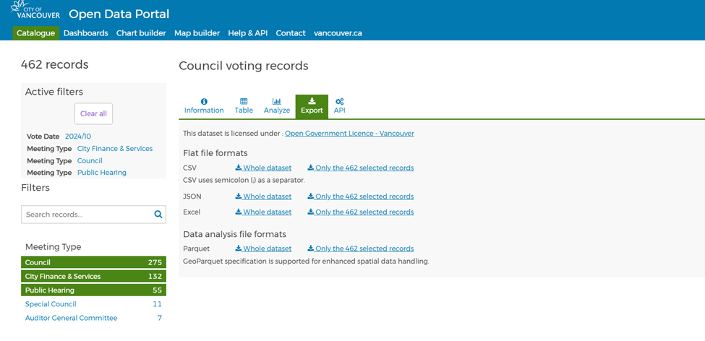 For data ingestion, I selected the dataset "Council voting records" and applied filters for the year 2024 (October) and specific meeting types: We also have “City Finance & Services” and “Public Hearing”. Also, the data set contains a feature to define the voting year as 2024 and the voting month as October. This reduced the data set to 462 records, according to the records shown in the data set portal on 11/23/24. Next, I downloaded the filtered records in Excel format. After that, I had to go into my AWS console to create buckets in S3 for storage and analysis.

Figure 32 S3 Buckets created for the Data Analytic Platform (Source: Author)

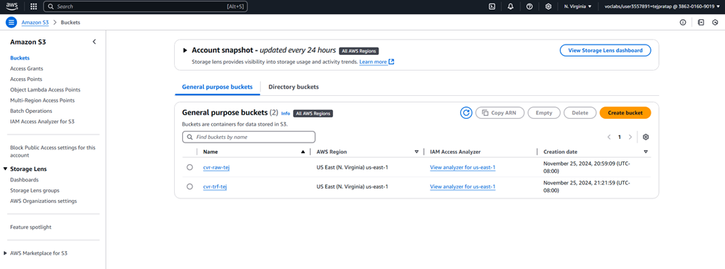

First, I created two separate buckets in AWS S3: cvr-raw-tej for the storage of raw and unadulterated datasets, including a filter Excel dataset I obtained from the City of Vancouver website, and cvr-trf-tej for the storage of cleansed and pre-processed-data-. The cvr-trf-tej bucket will contain DataBrew job output, including structure folders created by DataBrew, such as the results and data created or modified by users.

Step 2: Data Profiling

Figure 33 Folders within the transform bucket for data cleaning and profiling (Source: Author)

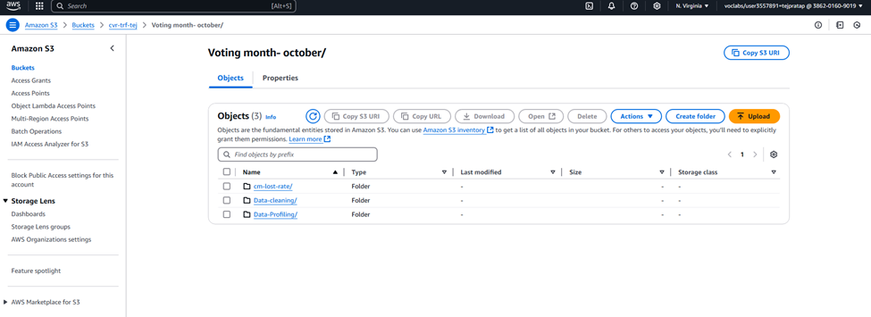

Figure 34 The initial state of the data before profiling needs some renaming (Source: Author)

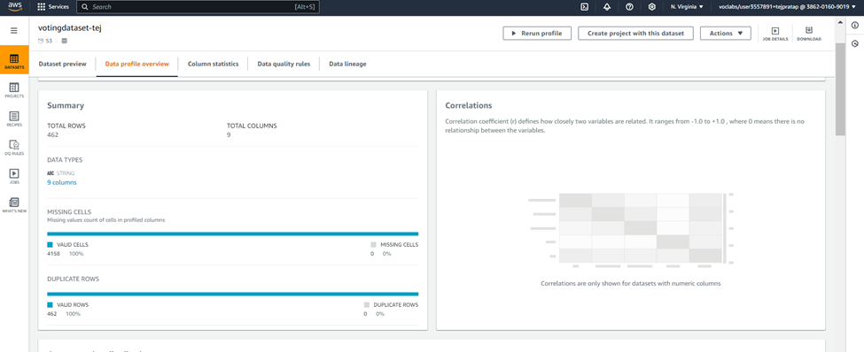

Having uploaded votingdataset-tej into AWS Glue DataBrew, I conducted the data profile analysis on the said dataset. It turned out that there were 462 rows and 9 columns in the overall data evaluation. Metrics of internal data quality: All cells in the dataset were valid; therefore, 0% were missing cells. There were no duplicate rows in the dataset, meaning 100% unique rows. The data type of all of the columns was stated to be a string. In addition, a correlation matrix was computed, though this was not possible since the dataset has no numeric features.

Figure 35 Dataset after profiling and cleaning, all the columns are now quality data (Source: Author)

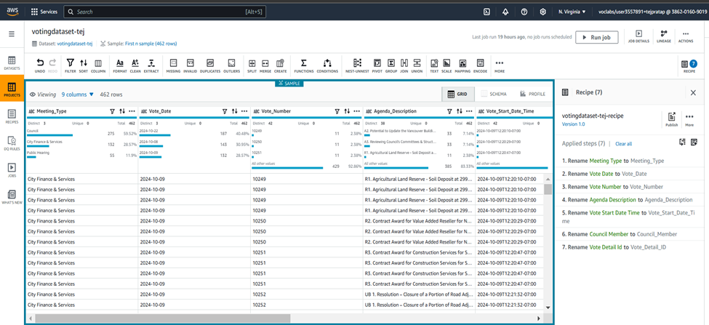

Step 3: Data Cleaning

Figure 36 Recipe and steps followed for data profiling and cleaning for dataset. (Source: Author)

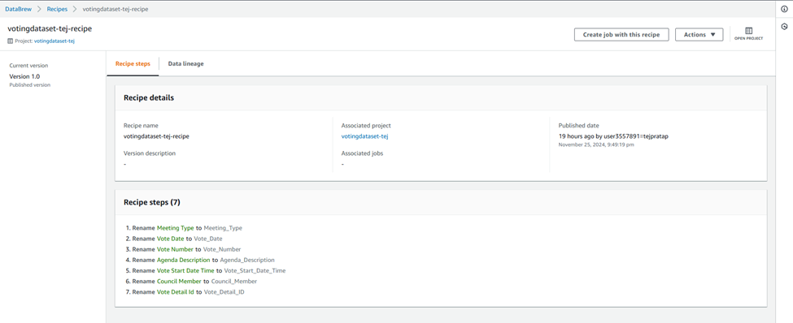

Several transformations were performed on DataBrew by running a recipe to clean data. Key modifications included renaming columns for clarity and standardization: Variables consisting of more than one word were modified to contain underscores, where Meeting Type was changed to Meeting_Type, Vote Date to Vote_Date, and Vote Number to Vote_Number and Agenda Description to Agenda_Description, and so on. The applied imputing strategy was the last valid value method because it gave the best result in handling null values. Vote_Start_Date_Time, like other related fields, was formatted to a standard date format to make their comparison easier. The final compiled data set was checked against the City of Vancouver’s database and has proven to be more than ninety percent accurate.

## Step 4: Data Pipeline Design

Figure 37 Pipeline for descriptive analysis question resolution and data processing. (Source: Author)

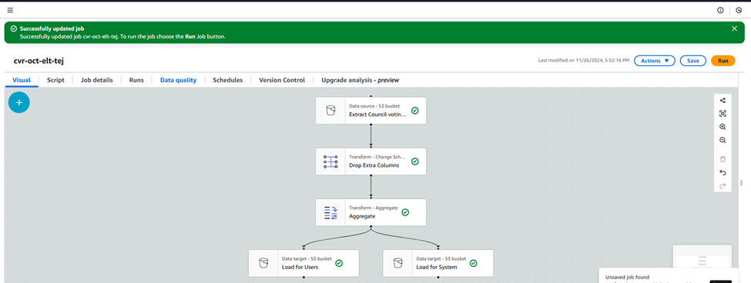

After that, the following workflow loaded the data set from an S3 bucket named ‘Extract Council voting Records’. Some additional columns have been omitted to keep only the necessary ones. An aggregation step was then applied to bring out the concluding summary of the data and the answer to the query, which is “How many Candidates have taken part in Council elections in the month of October”. The processed data was stored in two S3 buckets: A second was labeled ‘Load for Users,’ and the other one ‘Load for System.’ This meant that the supply was controlled so that the data chain was kept clean for efficient analysis.

Figure 38 Outcome of the pipeline for Council voting record for October in Vancouver (Source: Author)

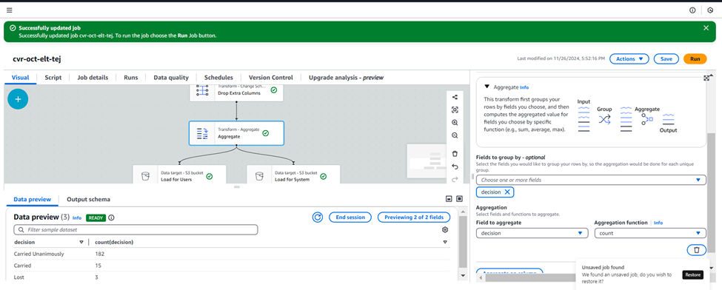*Figure Figure Screenshot of the data to verify that the pipeline achieved the same results. (Source: opendata.vancouver.ca)*

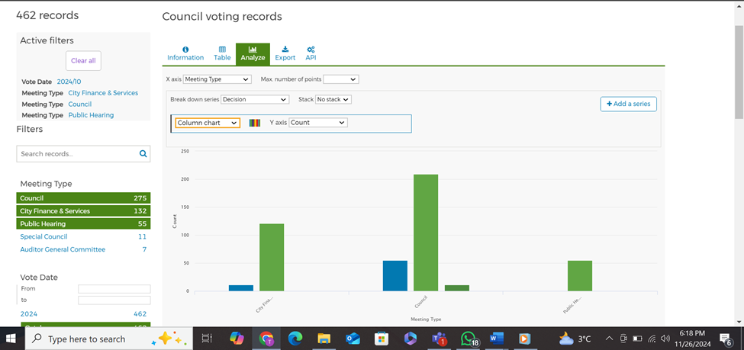

After comparing the results of the AWS Glue pipeline with the City of Vancouver Datapoint, the transfer to AWS was made efficiently and smoothly. This chart indicates that 275 Council meetings and 132 City Finance & Services meetings, and the rest of the categories, also match in both sets. This affirms the efficiency of the AWS platform for processing and computations as well as analysis.

## Exploratory Analysis

Question: - What’s the rate of lost council members in Vancouver voting in October 2024

*Figure 39 Draw.io Diagram for Exploratory analysis data analytic platform (Source: Author)*

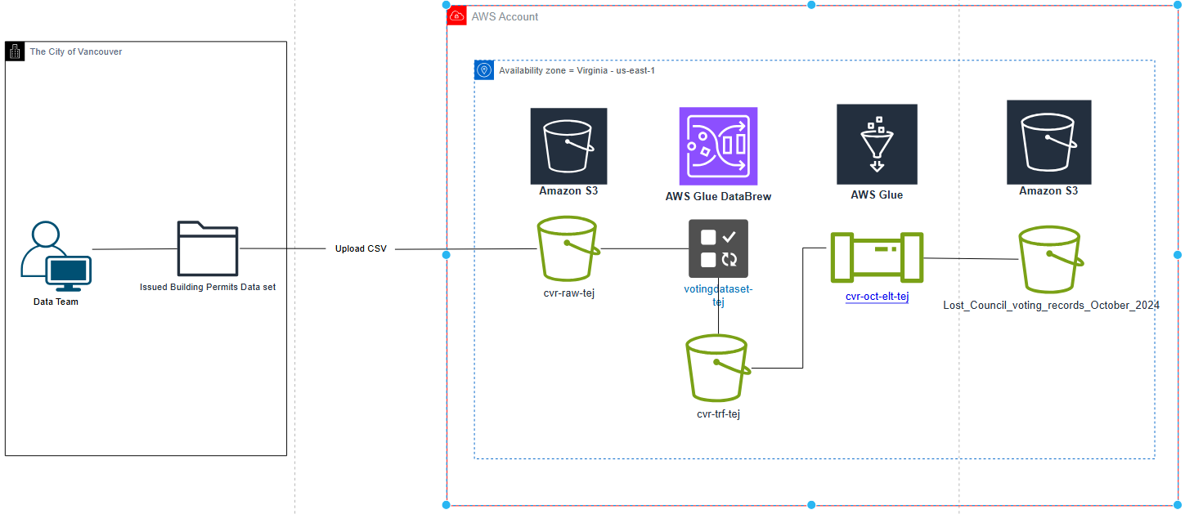

Step 1: Data Ingestion

*Figure 40 Data ingestion was the same process since the same dataset is used for exploratory analysis. (Source: Author)*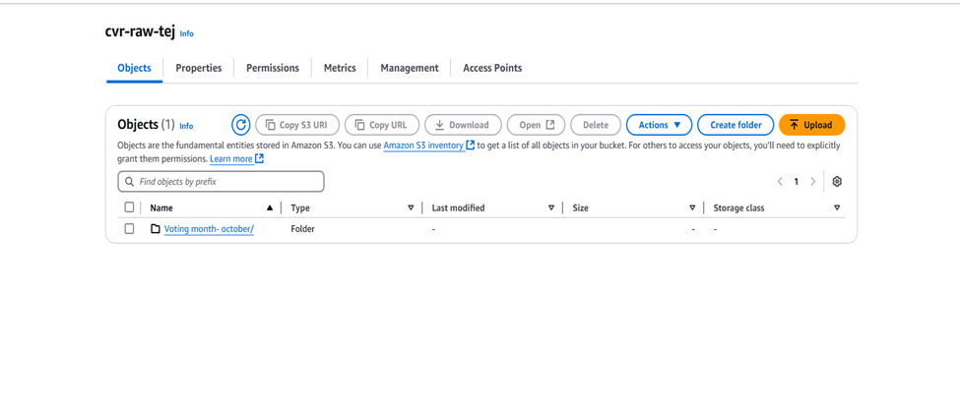

The data ingestion process was the same as when performing the descriptive analysis because the same dataset was used to answer the exploratory analysis question

Step 2: Data Profiling

*Figure 41 Data profiling output locations for both System and User. (Source: Author)*

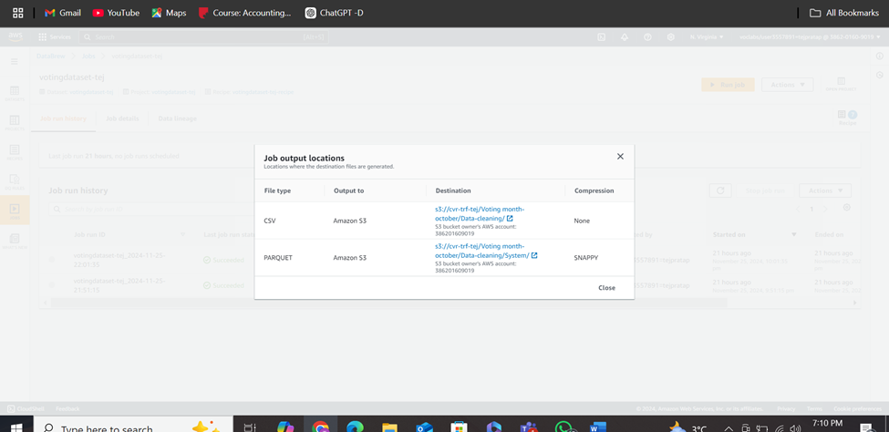 Data profiling stayed the same and extra attention was paid to the types of permits in this column since it was necessary to answer this question.

## Step 3: Data Cleaning

Figure 42 Profiling is the same as the previous one as the data is same (Source - Author)

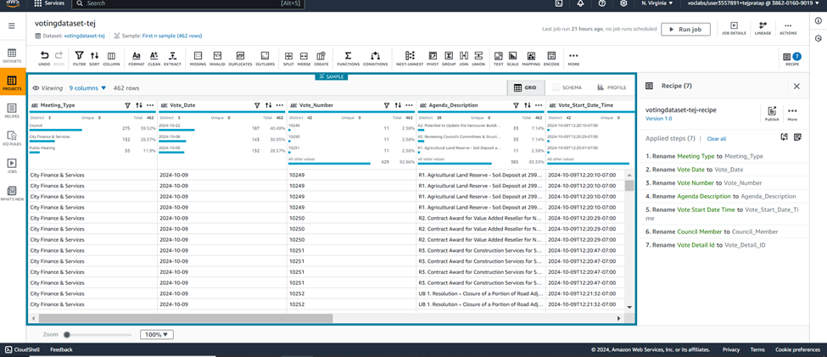Data cleaning is the same for this as its data is the same as above.

## Step 4: Data Pipeline Design

Figure 3 Data preview showcases the rate of council members lost election in the month of October 2024 (Source: Author)

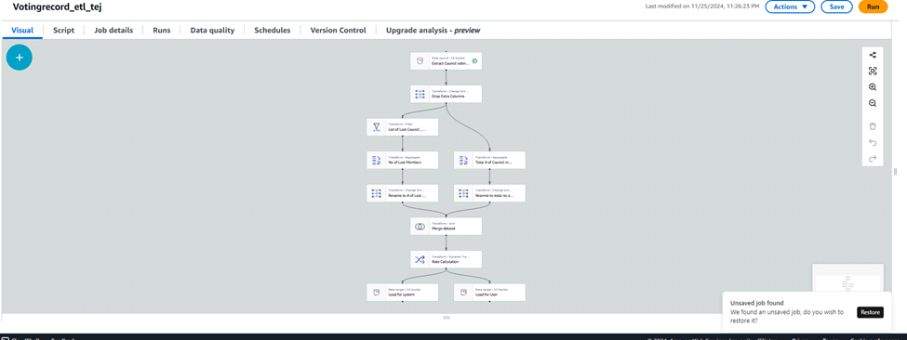

The data pipeline for the exploratory analysis is done systematically. This dataset is assumed to be stored in an S3 bucket and is, therefore, loaded initially, and all the extraneous columns are deleted. The data is then split into two streams: one dedicated to filtering Council-related records and the second one to filtering the meeting-specific data. Each stream is first aggregated to calculate the counts, after which its schema is altered to give it consistent names for each column. Last, the datasets are merged for comparison with the overall results to predict the Council voting trends for 2024.

Figure 44 Figure Screenshot from The City of Vancouver database that shows percentage to verify. (Source Author)

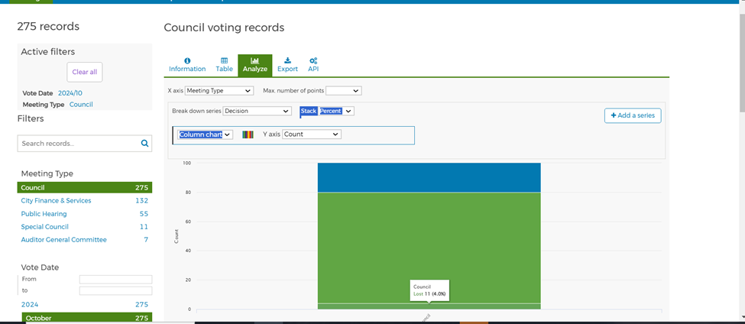 The derived node on voting records shows that the ’Lost’ Council decisions represent 4% of all voting records, as it is depicted in the above chart. The data provides endorsement to the processed dataset in AWS Glue, which was downloaded, crawled from the City of Vancouver website. It is possible that any minor variances in percentages can be associated with different timing in updating the datasets, the total number of records included in the analysis was 275 for October 2024.

# DAP Estimated Cost (Teamwork)

Figure 45 Estimated Cost for DAP 1 (Source Author / calculator.aws)

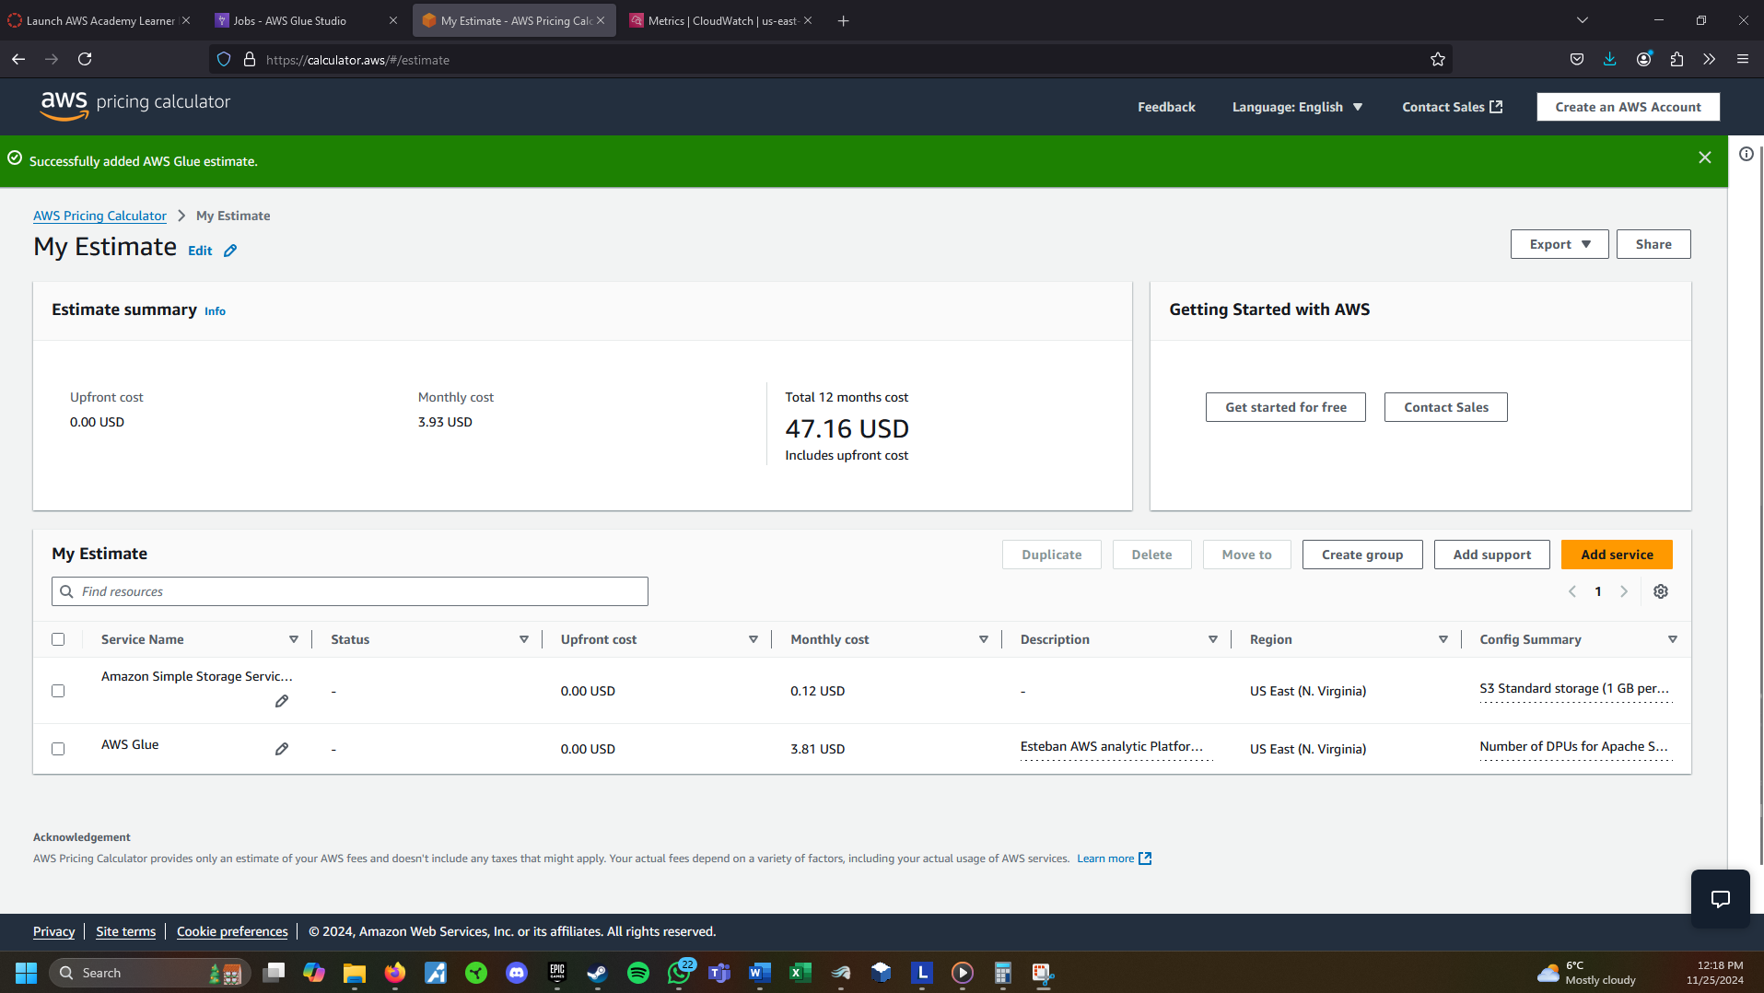

Figure 46 Estimated cost for DAP 2 (Source Author / calculator.aws)

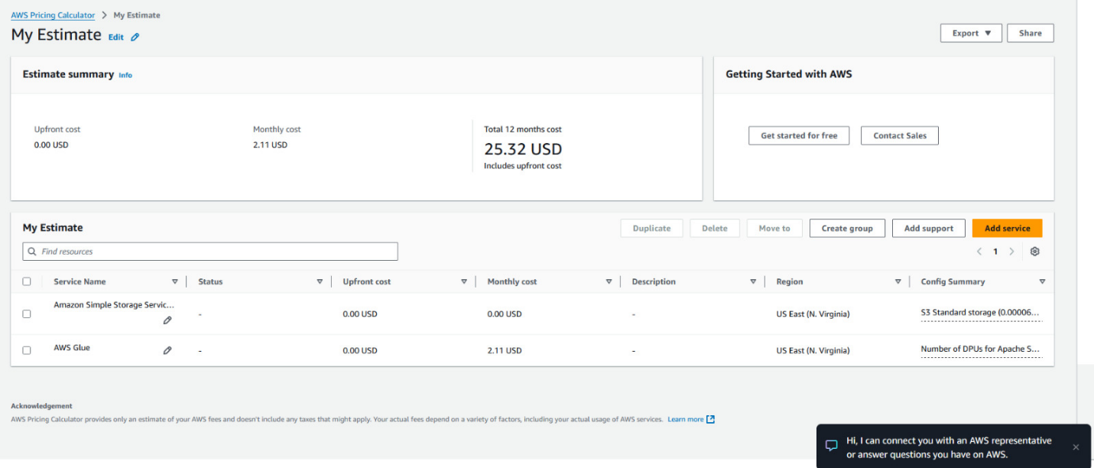

Figure 47 Estimated Cost for DAP 3 (Source Author / calculator.aws)

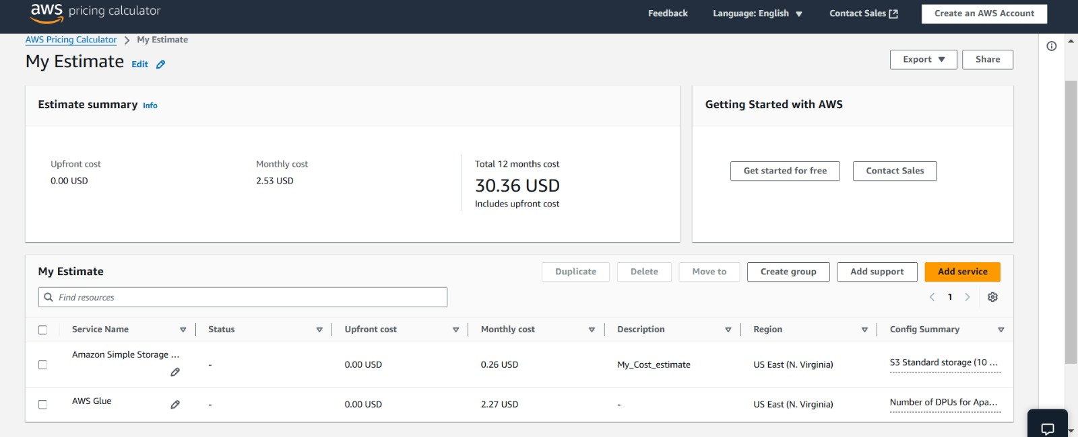

The estimated cost to run our Data Analytic Platform is 8.57 per month or 102.84 per year. The cost parameters used were S3 Standard storage tier, basing the cost on the current size of our S3 buckets. AWS Glue ETL Jobs, using the time it took to run our jobs as a reference. This data analytic platform offers the City of Vancouver the opportunity to migrate to a cost-effective, scalable and secure solution to manage and analyze their datasets. These costs are based on the size of the city of Vancouver datasets and ETL job runs. Migrating to AWS, the city of Vancouver benefits from improved accessibility, reduced overhead costs associated with having and maintaining an on-premises infrastructure, and the ability to scale operations seamlessly, when necessary, as datasets grow. Using our DAP, we ensure that decision-making capabilities increase while maintain a budget-friendly approach and providing an opportunity to invest in a more efficient data platform that fits the city of Vancouver needs.

# References

AWS Academy. (n.d.). https://awsacademy.instructure.com/

AWS Pricing Calculator. (n.d.). https://calculator.aws/#/

Issued Building Permit [Online Image]. (2024). City of Vancouver. <https://opendata.vancouver.ca/explore/dataset/issued-building-permits/analyze/?refine.issuedate=2024&refine.geolocalarea=Downtown&%3D>

Home - city of Vancouver open data portal. (n.d.). https://opendata.vancouver.ca/pages/home/